CUSTOMER SERVICE DESK WORKFLOW

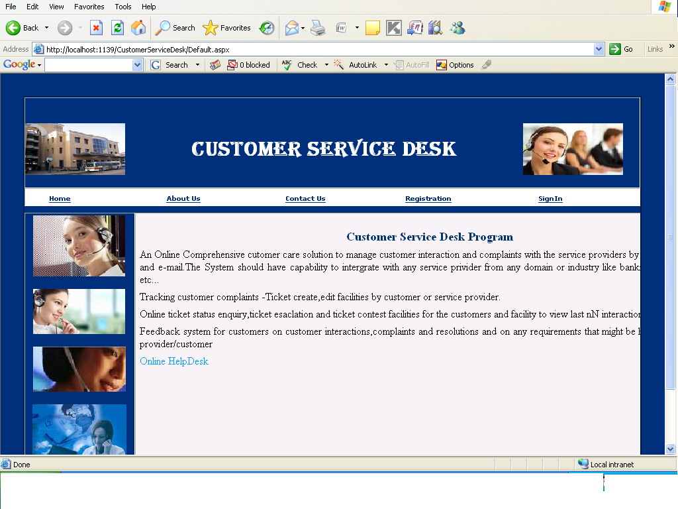

Page Name: Home Page of Customer Service Desk

Fields:nill

Process:nill

Table: nill

Stored Procedures:nill

Remarks:nill

About us:

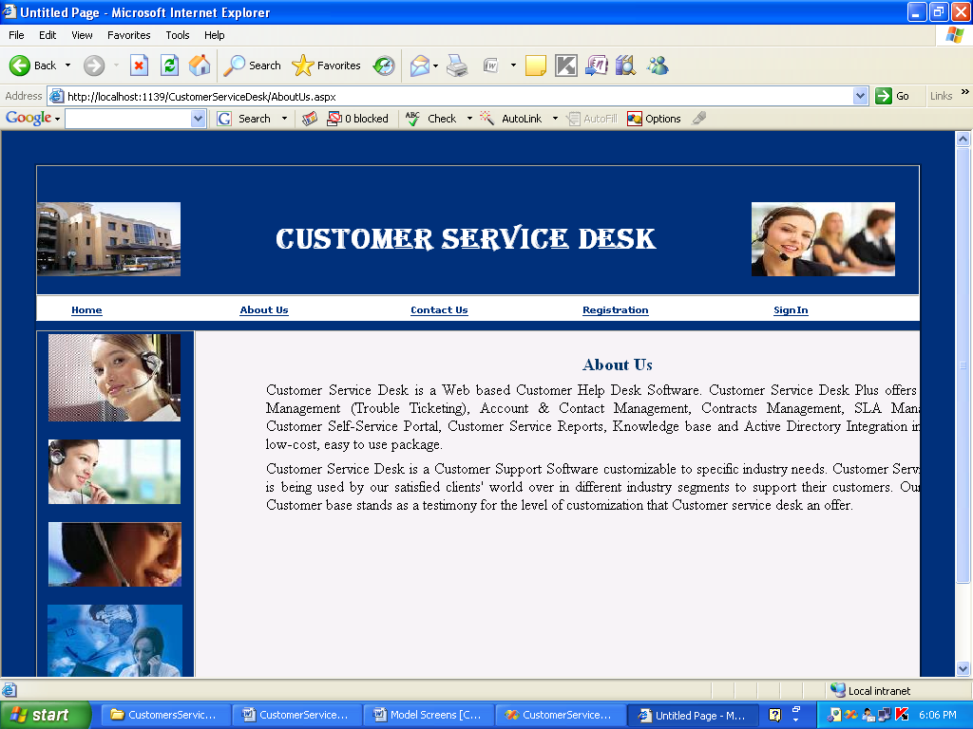

Page Name: About Us Page

Fields:nill

Process:nill

Table: nill

Stored Procedures:nill

Remarks:nill

CONTACTUS:

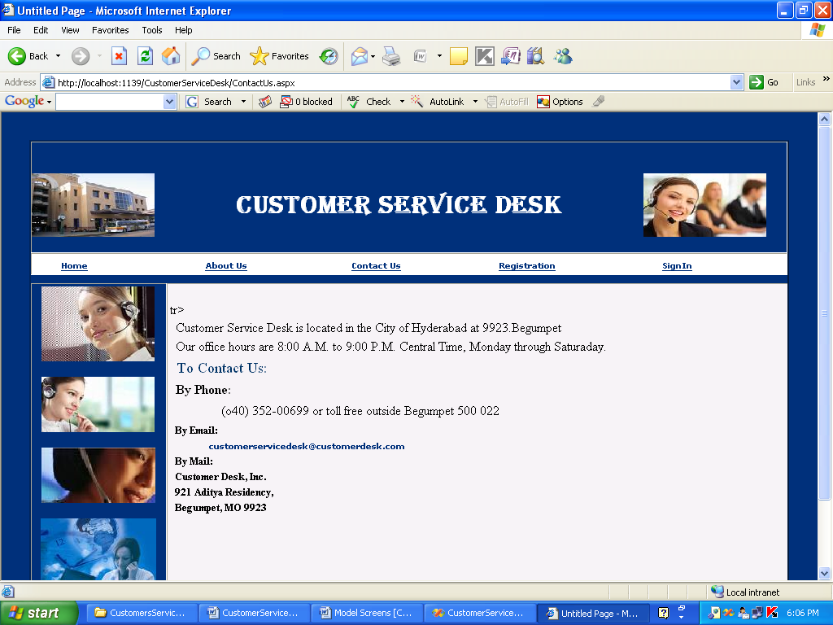

Page Name: Contact Us Page

Fields:nill

Process:nill

Table: nill

Stored Procedures:nill

Remarks:nill

Customer Registration:

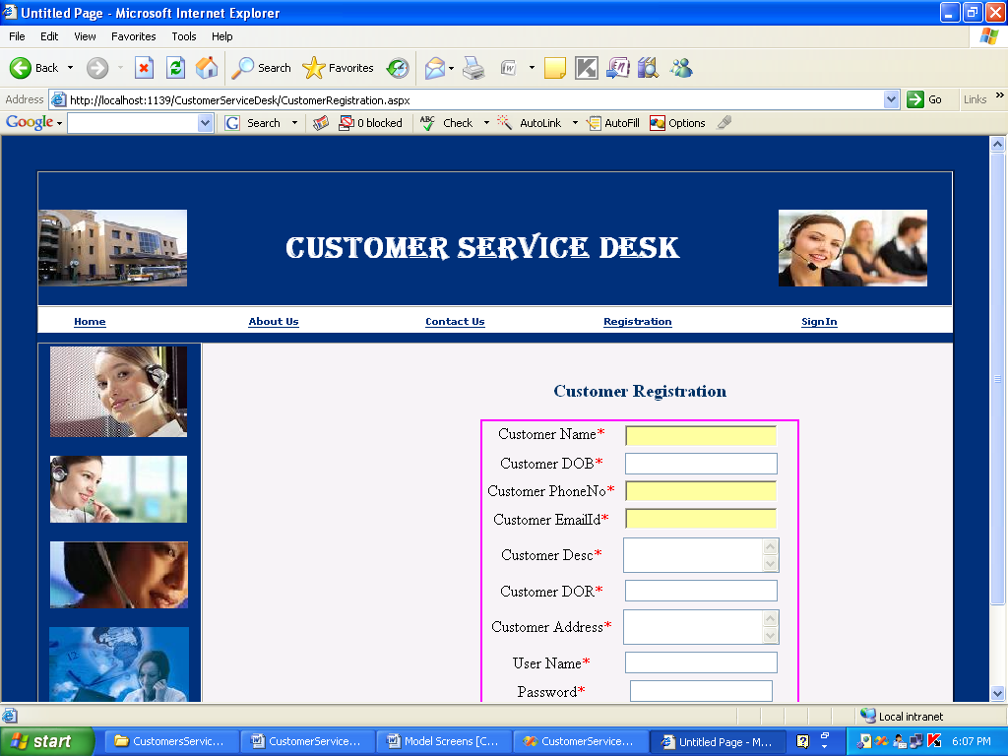

Page Name: Customer Registration Page

Fields:Customer Name,customer DOB,Customer ph no,Customer Desc,……..

Process:customer enters his details

Table: tbl_Customer

Stored Procedures:sp_InsertCustomer

Remarks:nill

ADMIN HOME PAGE:

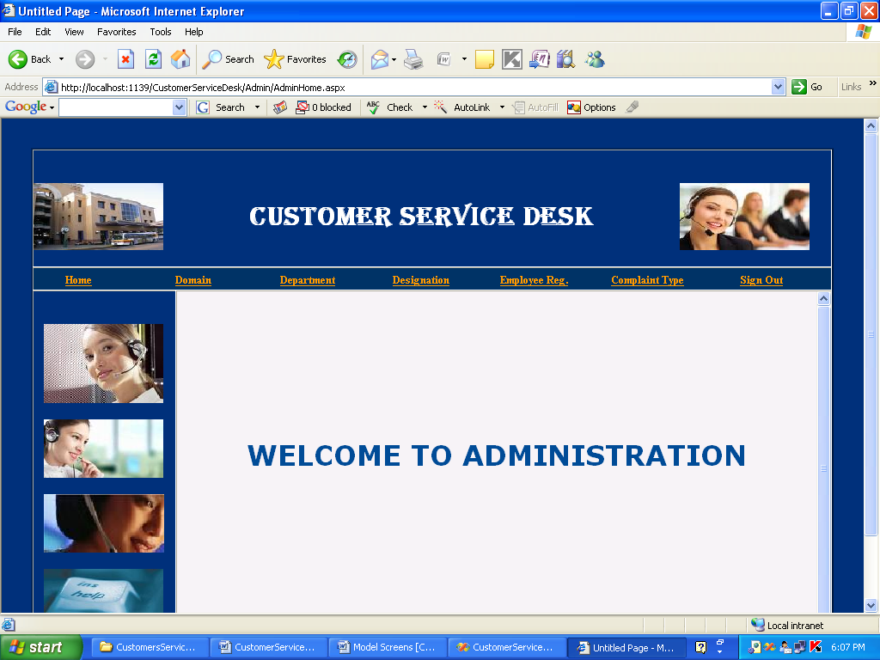

Page Name: Admin Home Page

Fields:nill

Process:nill

Table: nill

Stored Procedures:nill

Remarks:nill

DOMAIN PAGE:

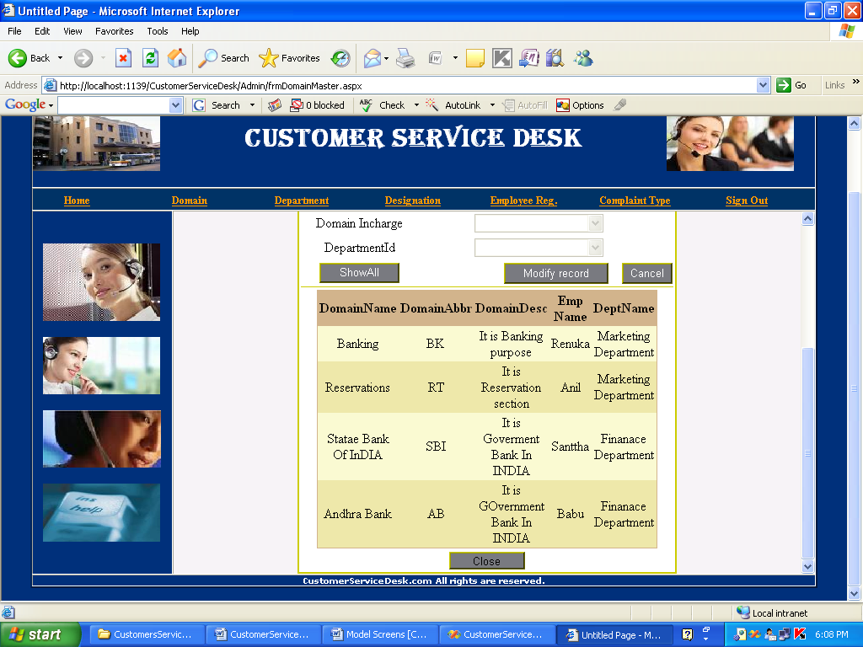

Page Name: Customer Domain Page

Fields:Domain Incharge,Department Id

Process:nill

Table: tbl_Domain

Stored Procedures: sp_GetDomainIncharges, sp_GetDomainDataByDomainId, sp_InsertDomain

Remarks:nill

DEPARTMENT PAGE:

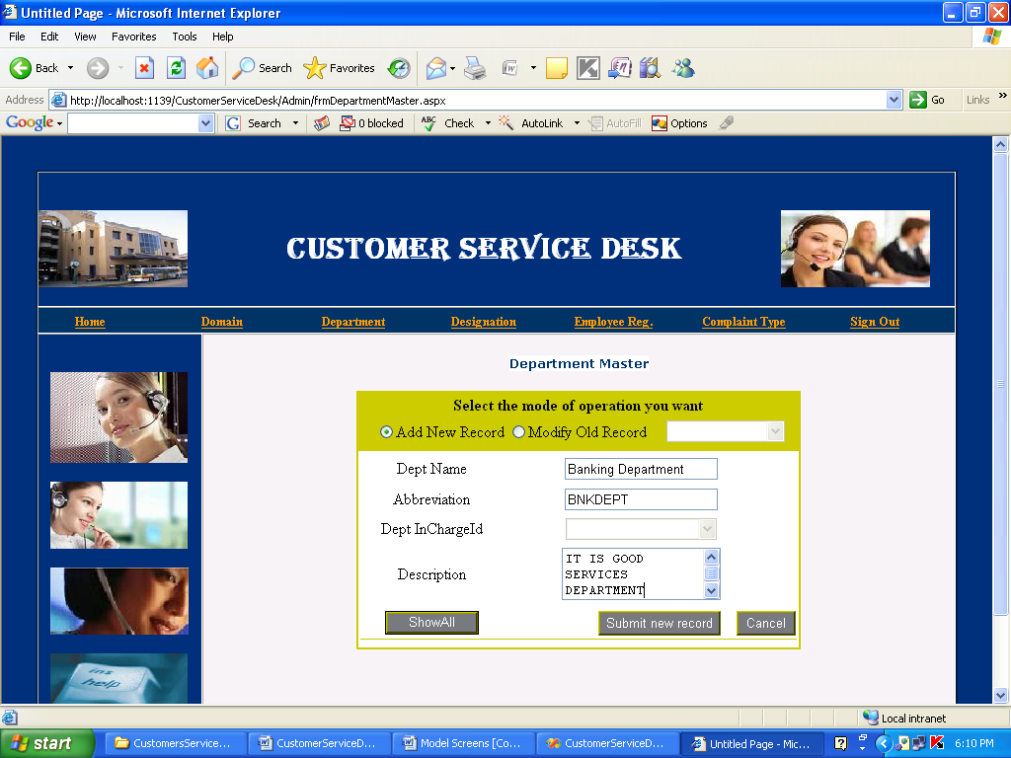

Page Name: Department Page

Fields:DeptName,Abbrevations,DeptInchargeId,Description

Process:Admin can add Department details

Table: tbl_Department

Stored Procedures: GetDeptDataByDeptId.

Remarks:nill

DESIGNATION MASTER PAGE:

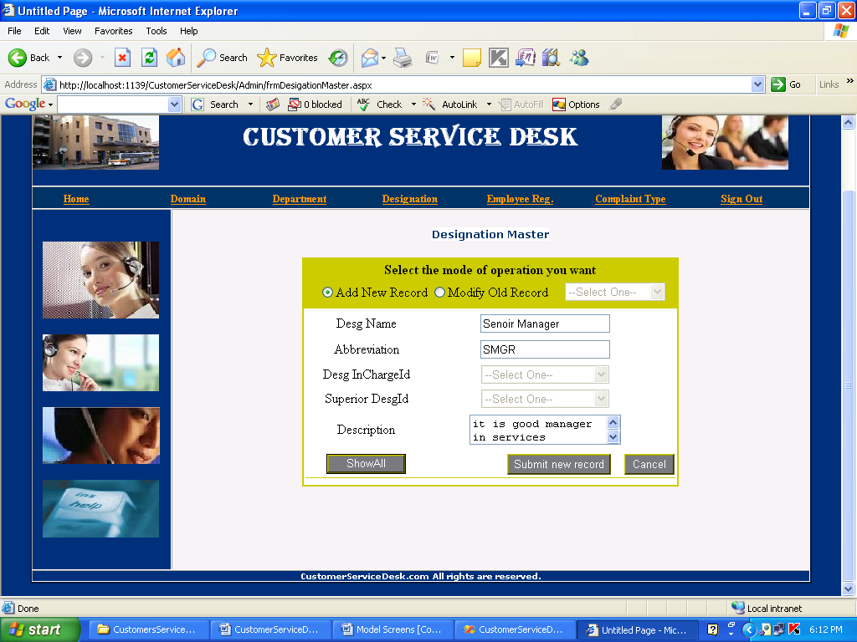

Page Name: Admin Designation Page

Fields:DesgName,Abreviation ,dasg Incharge Id,Supior Desg Id,description

Process:Here Admin can Add or modify the Designation Record

Table: tbl_Designation

Stored Procedures: sp_GetAllDesgMasterData, sp_InsertDesgMaster, sp_UpdateDesgMaster

Remarks:nill

EMPLOYEE REGISTRATION:

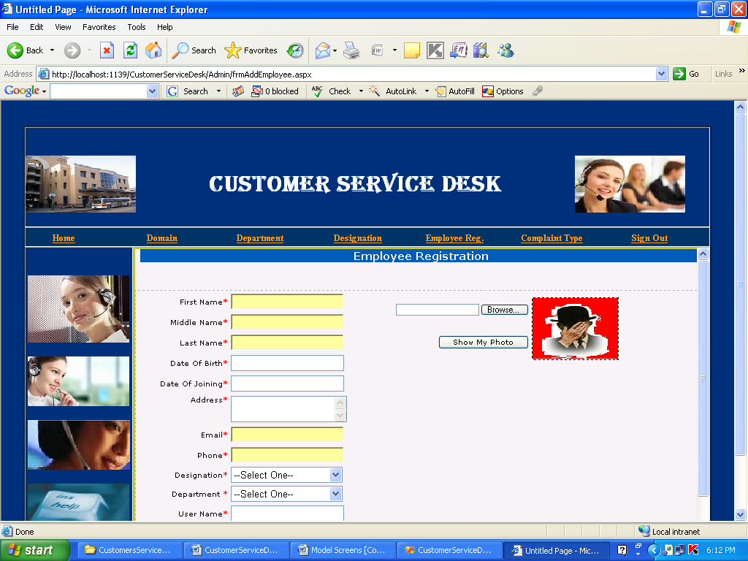

Page Name:Admin Adding employee Details

Fields:First Name,Middle Name………

Process:Admin enters the Employee details

Table: tbl_Employee

Stored Procedures: sp_InsertEmployeeDetails

Remarks:nill

COMPLAINT TYPE MASTER:

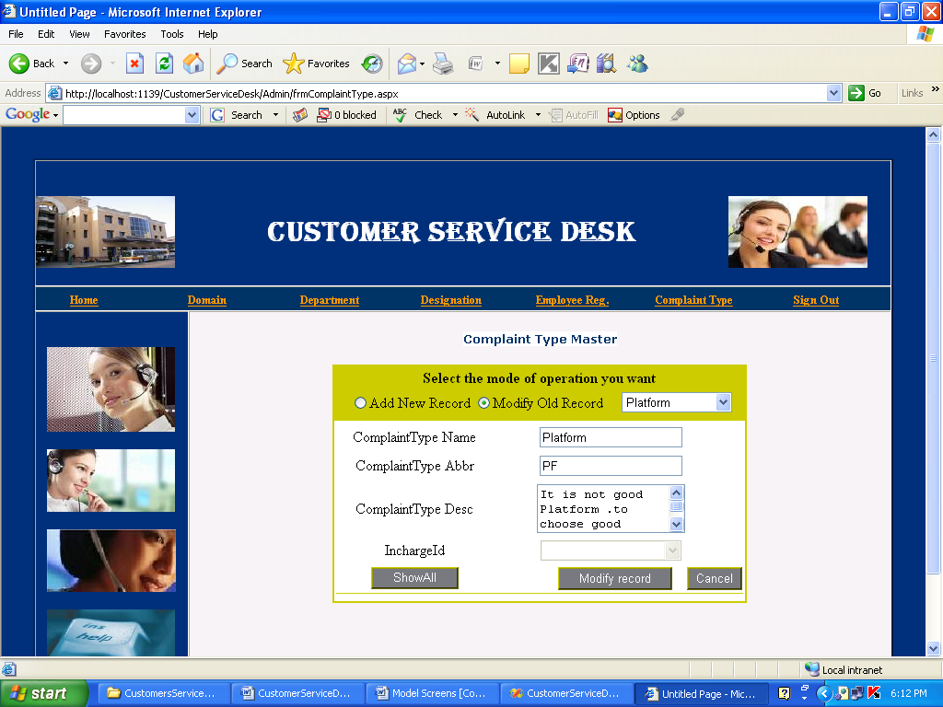

Page Name: Admin Complaint Type Master page

Fields:Complaint Type Name,Abreviation,Desc

Process:Here Admin add the Complaint Types

Table: tbl_ComplaintType

Stored Procedures:sp_Complaint Type,sp_ComplaintType.

Remarks:

Employee Home page:

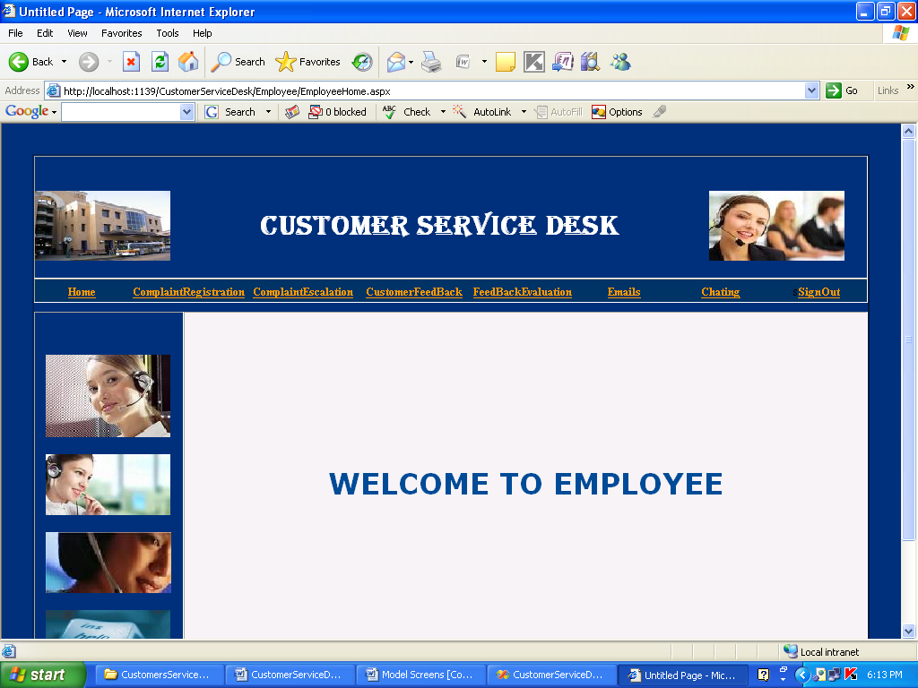

Page Name: Employee Home page

Fields:nill

Process:After Employee enters his credentials will enter into the Employee Home Page

Table: tbl_Login

Stored Procedures:spLoginChecking.

Remarks:

Employee Complaint Regisrtation:

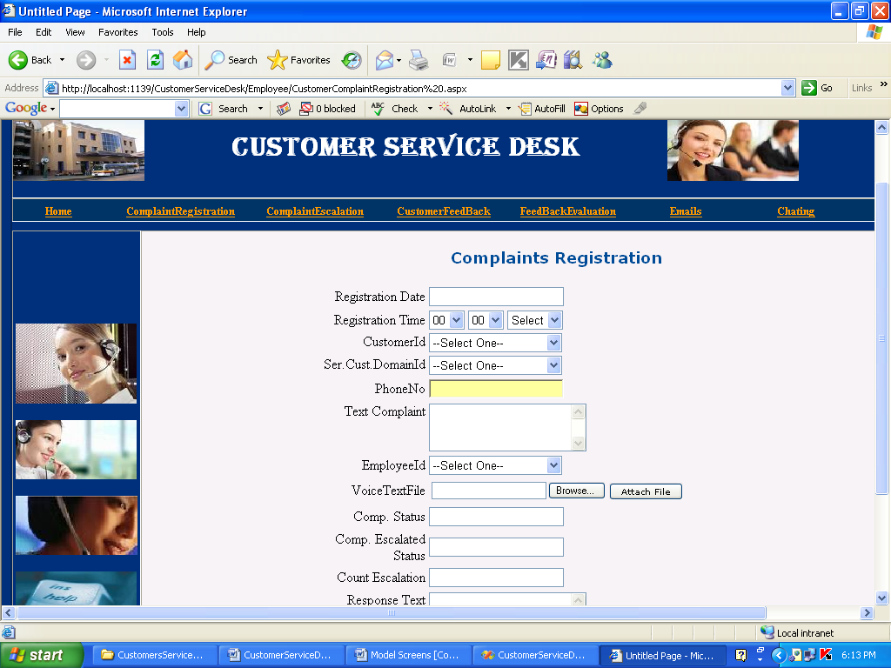

Page Name:Employee Complaint Registration Page

Fields:Registration date,Registration Time,Customer Id………

Process:Here Employee enters the Customer related complaints details

Table: tbl_CustomerComplaintsRegistration.

Stored Procedures:sp_InsertCustomerComplaintRegistration

Remarks:nill

Customer Feedback:

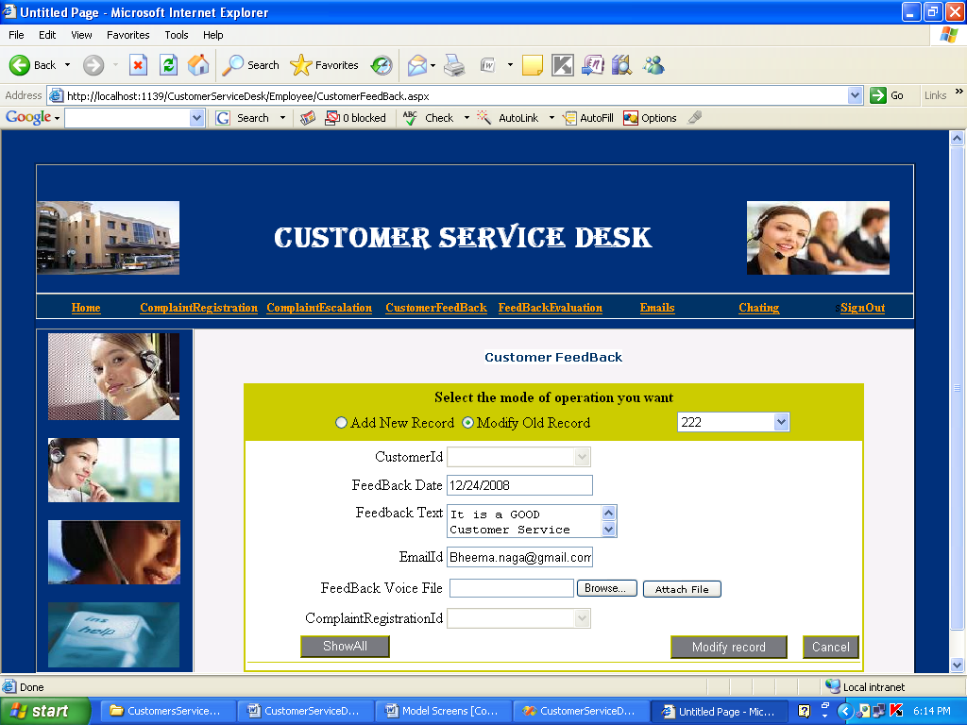

Page Name: Customer feed Back Page

Fields:CustomerId,Feedback Date,FedbackText,EmailId……

Process:Here the Customer can Add or modify the feed back given by him.

Table: tbl_CustomerFeedback

Stored Procedures: sp_GetAllFeedBackData, sp_UpdateCustomerFeedback

Remarks:nill

Composing mail by Employee:

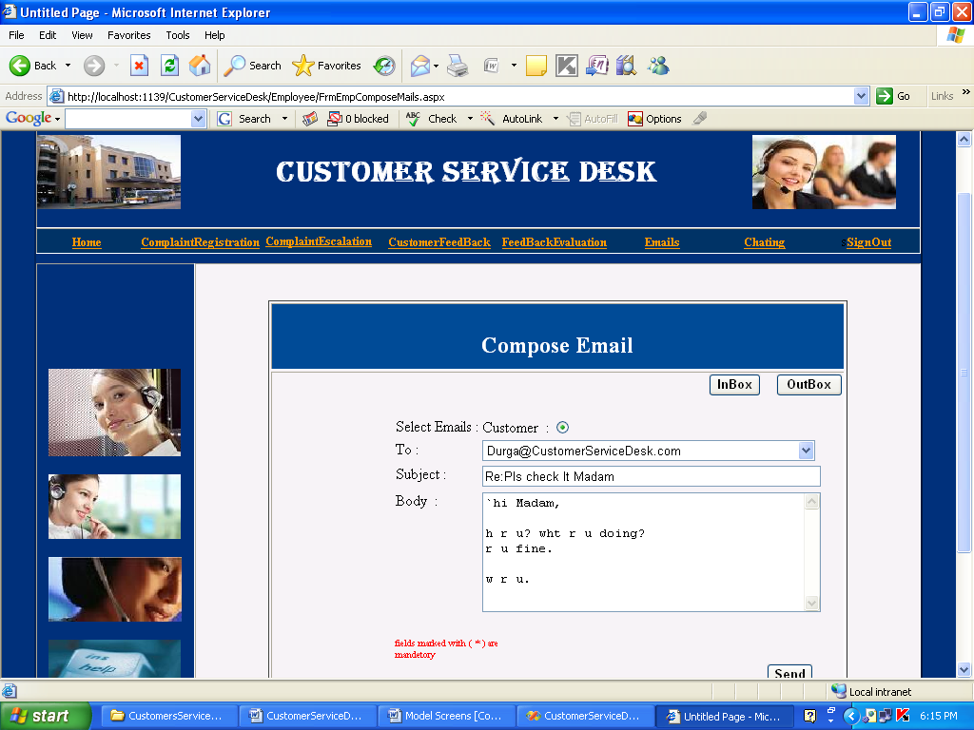

Page Name:Employee cMail Compasing page

Fields:To,Subject,Body……

Process: Employee sending mailreport to the desired customer.

Table: tbl_ServiceCustomers

Stored Procedures:sp_InsertServiceCustomer

Remarks:nill

Employee chat room:

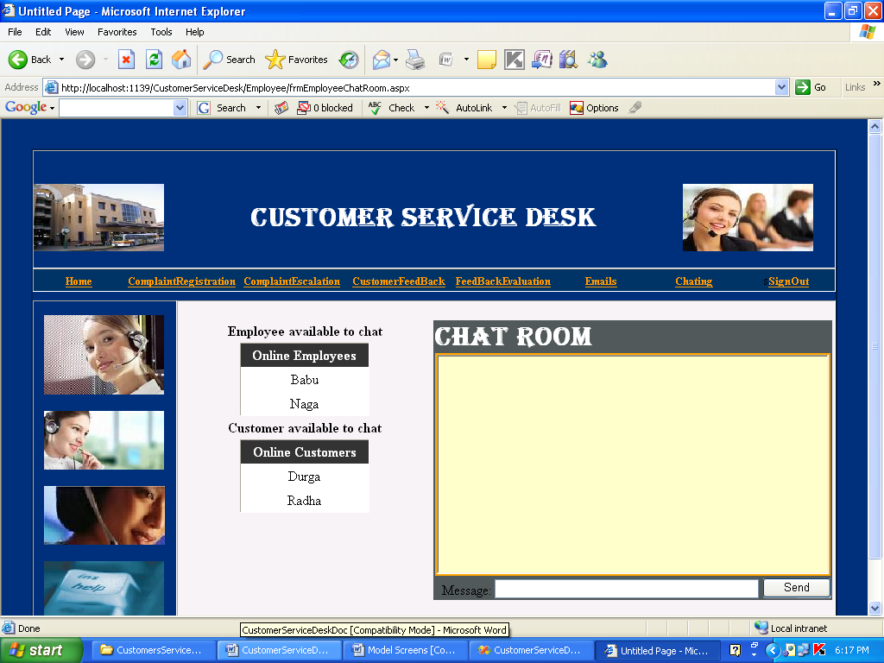

Page Name: Employee Chat Room Page

Fields:
Online Employees,OnlineCustomers

Process:Where the employee can chat with employees and customers

Table: Tbl_CustomerOnline,tb_Employee Online

Stored Procedures: sp_GetOnlineCustomerData, sp_GetOnlineEmployeeData

Remarks:nill

Viewing outbox mails:

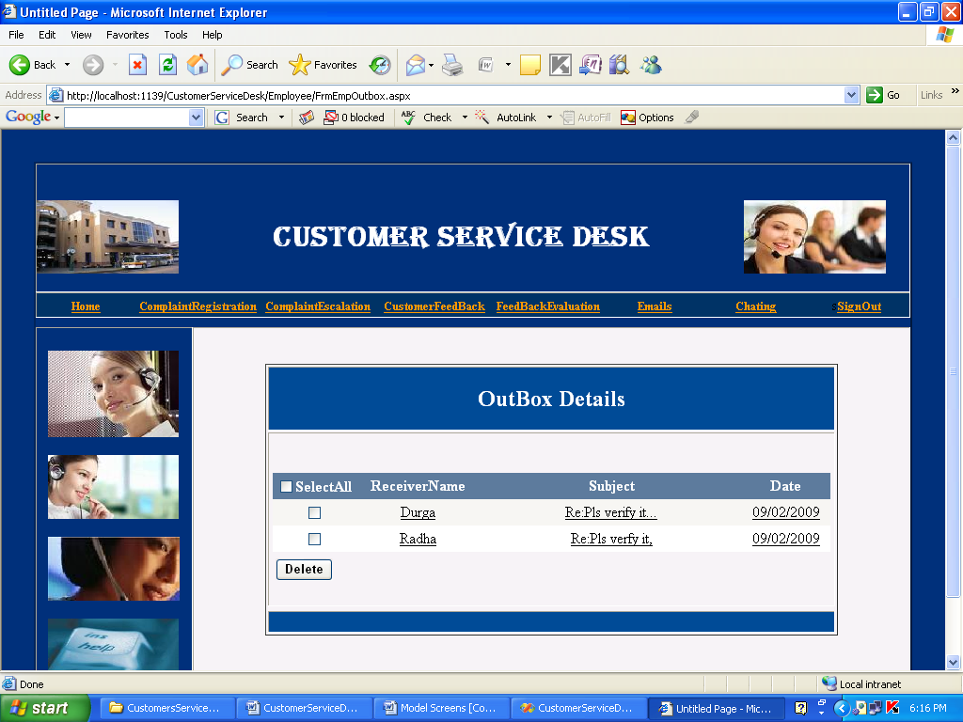

Page Name: Employee Viewing OutBox details page

Fields:nill

Process:Where Employee Can View The Mail Send Report by him.

Table: tbl_Email,tbl_EmailDetails

Stored Procedures:sp_GetEmployeeEmails

Remarks:nill

Employee Logout Page:

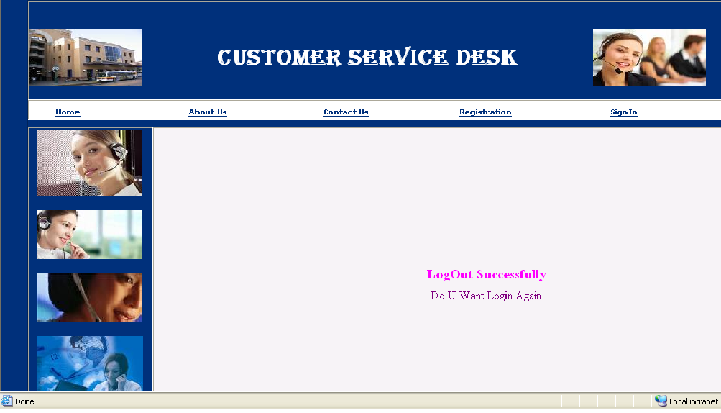

Page Name: Employee,Admin,Customer logout Page

Fields:nill

Process:nill

Table: nill

Stored Procedures:nill

Remarks:nill

